I think Kate’s doughnut is a work of genius and I wanted to recreate the idea in an editable form that can be generalized for all types of systems, for exampe an individual business or any other thing. I have written a program in FMS Logo, which is available for free here: https://fmslogo.sourceforge.io/ The program I wrote is listed below with line numbers and notes to the right (you only need copy and enter the program instructions in the left column). You can change the radius of the CIRCLE commands (in FMSLogo use 125 units per inch). You can edit the colors using RGB codes as well as the divisions for the inner and outer rings by changing the number of repetitions on lines 19 and 29, the degrees as parts of 360º on lines 21 and 30 (This image has 5 divisions of 72 degrees, but you can use whatever you like). After running the FMS Logo program,I save the basic doughnut as a .bmp file, place it in a Word document and add the lables with the Insert -> Shapes menus. I am licensing the image under CC BY SA Larry Marquardt feel free to modify and use as you see fit, but please provide attribution.
Have fun, and I hope it’s useful.
CIRCLE 300  SETFLOODCOLOR [255 128 0]  FILL  CIRCLE 225  SETFLOODCOLOR [255 0 0]  FILL  CIRCLE 215  SETFLOODCOLOR [0 204 0]  FILL  CIRCLE 140  SETFLOODCOLOR [255 0 0]  FILL  CIRCLE 130  SETFLOODCOLOR [0 128 255]  FILL  CIRCLE 55  SETFLOODCOLOR [255 255 255]  FILL  REPEAT 5 [  PU  RT REPCOUNT * 72  FORWARD 55  SETPENSIZE [10 10]  SETPENCOLOR [255 255 255]  PD  FORWARD 75  PU  HOME]  REPEAT 5 [  PU  RT REPCOUNT * 72  FORWARD 225  SETPENSIZE [10 10]  SETPENCOLOR [255 255 255]  PD  FORWARD 75  PU  HOME] | - Draw a circle filled with  - Set flood color RGB code  - Fill the circle with the color  - Draw a circle filled with  - Set flood color RGB code  - Fill the circle with the color  - Draw a circle filled with  - Set flood color RGB code  - Fill the circle with the color  - Draw a circle filled with  - Set flood color RGB code  - Fill the circle with the color  - Draw a circle filled with  - Set flood color RGB code  - Fill the circle with the color  - Draw a circle filled with  - Set flood color RGB code  - Fill the circle with the color  - Routine that repeats n times  - Stop drawing  - Count n and set to fraction of 360º (72)  - Move forward (don’t change)  - Set line width  - Set line color  - Start drawing  - Move forward (don’t change)  - Stop drawing  - Center and repeat n times  - Routine that repeats n times  - Stop drawing  - Count n and set to fraction of 360º (72)  - Move forward (don’t change)  - Set line width  - Set line color  - Start drawing  - Move forward (don’t change)  - Stop drawing  - Center and repeat n times
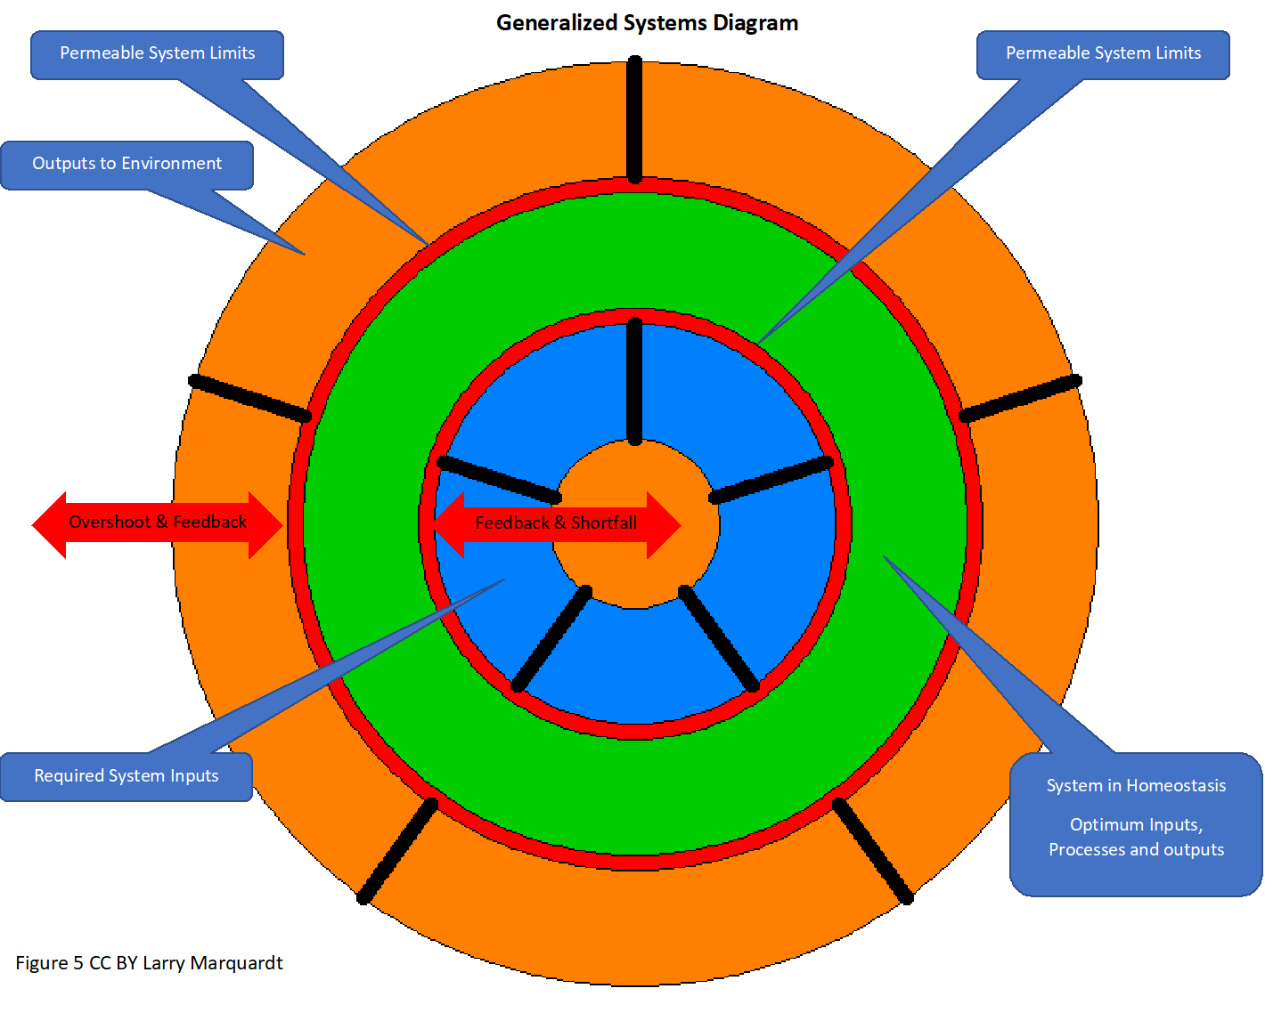
Independent systems (green area is the system per se).
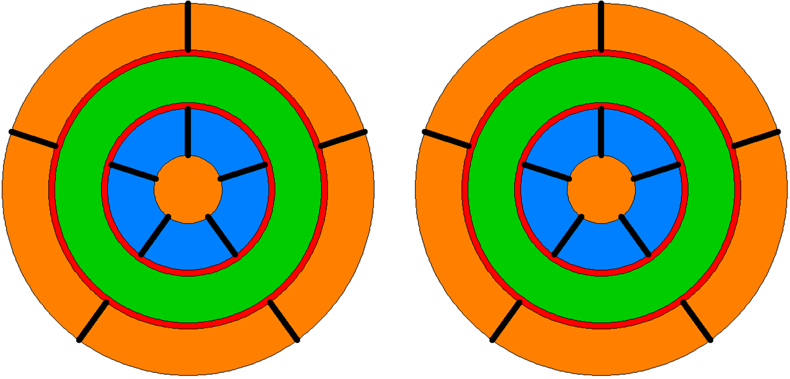

CC BY SA Larry Marquardt

Systems (green area) outputs (outer orange) begin to interact and be affected by each other.
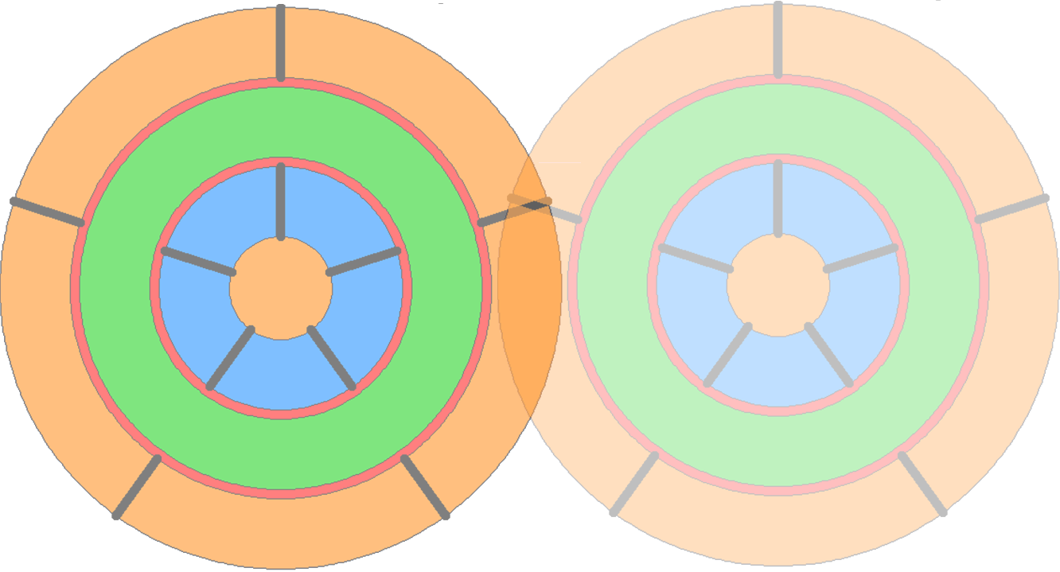
CC BY SA Larry Marquardt

Systems (green area) are fully interactive with external effects (outer orange) affecting each other’s inputs (blue). Cooperation or competition.
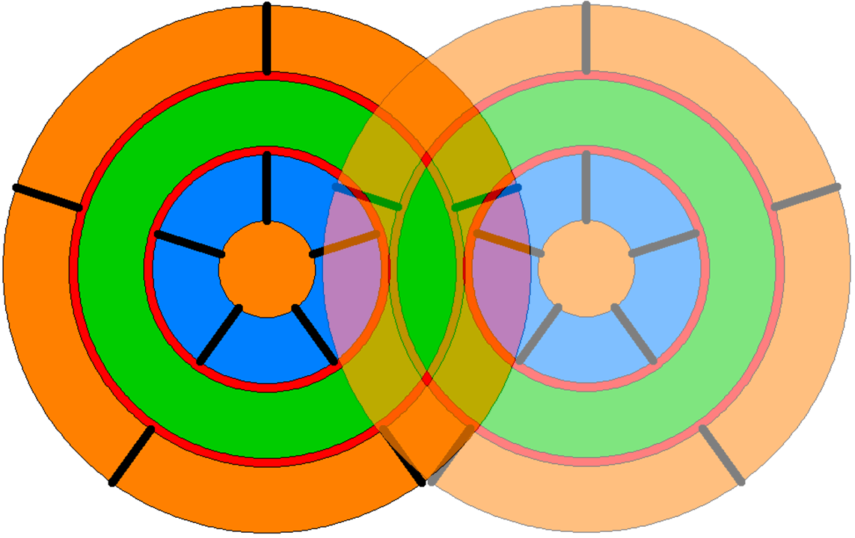
CC BY SA Larry Marquardt
Systems (green area) competing for inputs affecting each other’s inputs (blue area).
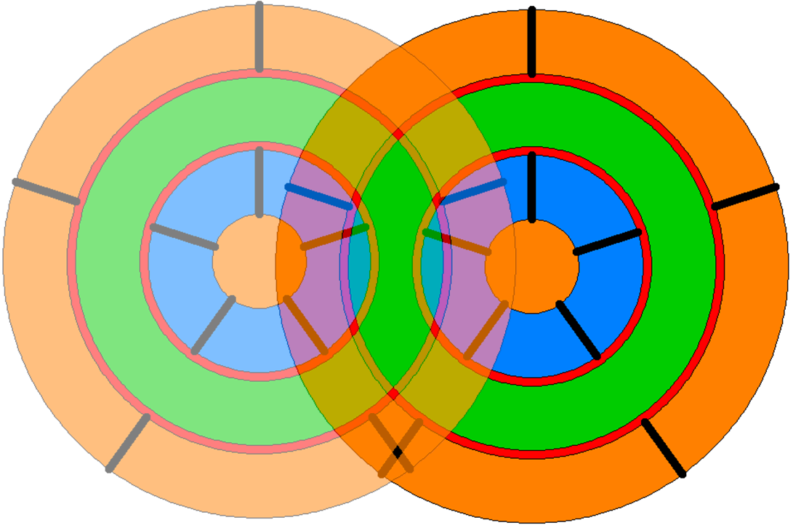
CC BY SA Larry Marquardt

Pair of systems (lighter shades) interacting to reproduce.
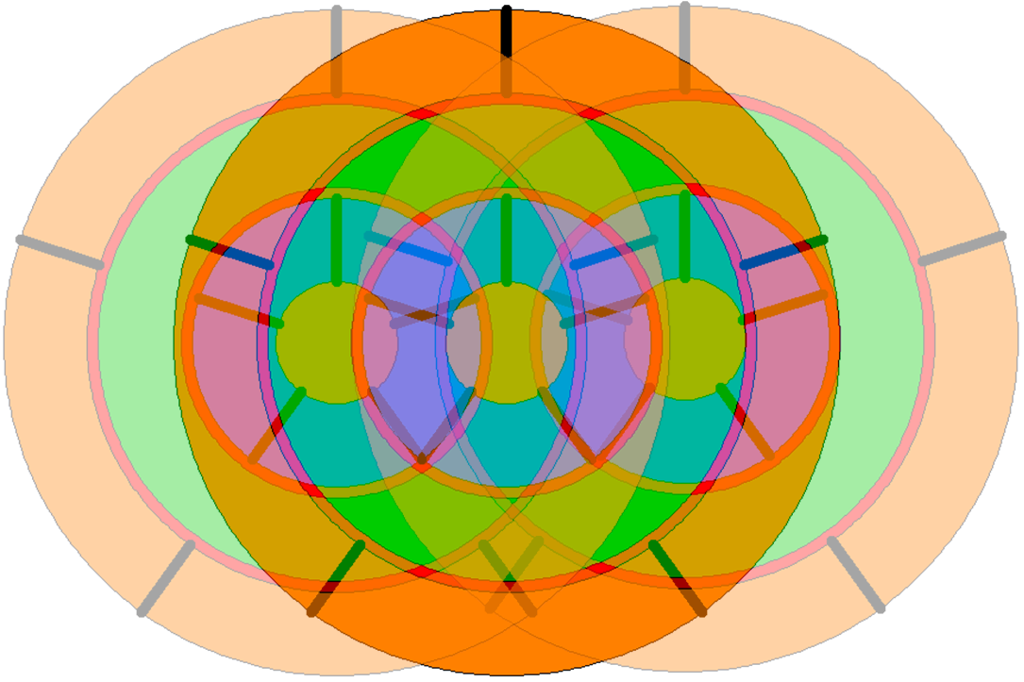
CC BY SA Larry Marquardt

